**Question 1:** Create class diagram of University Registration and using that diagram apply concept of forward engineering in Rational Rose.

**Input:**

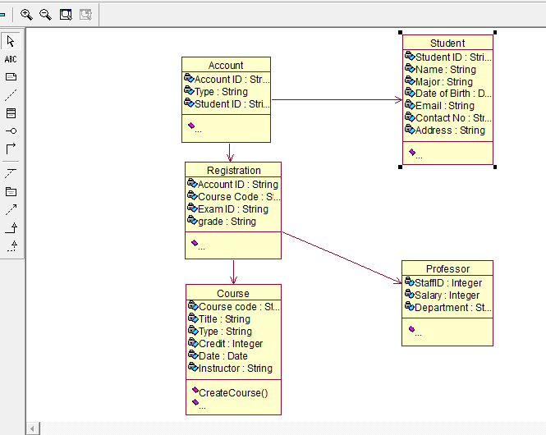

**Result:**

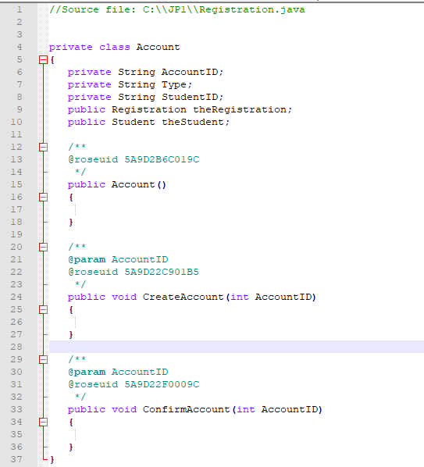

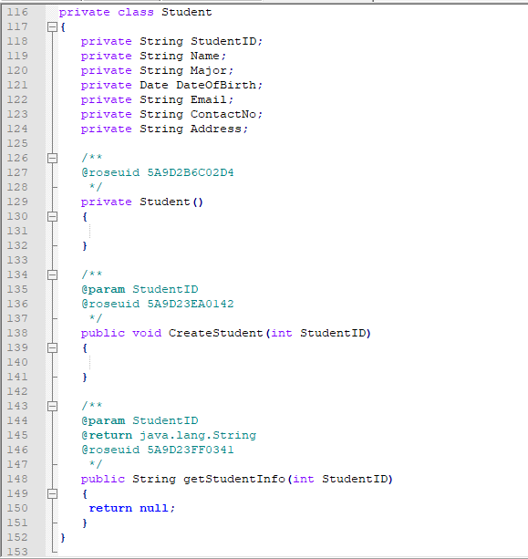

**Question 2:** Apply concept of reverse engineering to create the class diagram using java code in Rational Rose.

**Input:**

private class Account

{

private String StudentID;

public Account(){

}

public void CreateAccount(int AccountID)

{

}

}

private class Course

{

private String CourseCode;

private Date Date;

private String Instructor;

private Course(){

}

public void CreateCourse(int CourseCode) {

}

public void DropCourse(int CourseCode)

{

}

}

private class Professor

{

private Integer StaffID;

private String Department;

private Professor() {

}

public void CreateProfessor() {

}

public String getProfessorInfo()

{

return null;

}

}

private class Student

{

private String StudentID;

private String Name;

private Date DateOfBirth;

private String Email;

private String ContactNo;

private Student(){

}

public void CreateStudent(int StudentID)

{

}

public String getStudentInfo(int StudentID)

{

return null;

}

}

**Result:**

